Toyota Transportation Management System

Solution Architecture Document

Version 9.0

Revision History

|  |  |  |  |  |
| --- | --- | --- | --- | --- |
| **Date** | | **Version** | **Description** | **Author** |
| August 14, 2007 | | 2.1 | Initial Version for Marine Only | Bob Weber |
| August 22, 2007 | 2.5 | | FPR Team Final Version | Bob Weber |
| Sept. 4, 2007 | 2.5.1 | | Enhanced after EA Feedback | Bob Weber |
| Sept. 11, 2007 | 2.6 | | Enhanced after EA/ICE Feedback | Bob Weber |
| January 16, 2008 | 3.0 | | Elaboration SAD – Marine and TRE | Bob Weber |
| October 23, 2008 | 4.0 | | Elaboration SAD Updates for Phase 2 | Rick Wishon |
| December 12, 2011 | 5.0 | | Overall FP&R SAD – updating section 13 | William Hie |
| September 19, 2012 | 6.0 | | Inception TTMS OTM upgrade SAD updates – Section 13 | Karthi Mani |
|  |  | |  |  |
| October 12, 2012 | 8.0 | | 6.2 Upgrade related changes for the Direct XML insert and the POC for the Deviation SAW XML | Alpesh Purohit |
| March 20, 2015 | 9.0 | | Security – Section 8.0 Updated for TBG to TESS Migration for OTM, DRS & HYP | Sathish/Selva G/Selva P |

Approval

|  |  |  |  |
| --- | --- | --- | --- |
| **Date** | **Name** | **Department** | **Signature** |
|  | William Hie | IS FPR Project Team |  |
|  | Jose Loya | IS Enterprise Architecture |  |

Table of Contents

1. Introduction 7

1.1 Purpose 7

1.2 Scope 7

1.3 Problem Statement 8

1.4 TLS Business Context 10

1.5 References 12

2. Architectural Representation 13

2.1 Architectural Goals and Constraints 13

2.2 OTM COTS Integration 14

2.3 Legacy FPR System Bridging and Retirement 14

2.4 PeopleSoft Integration (Payables and Receivables) 15

2.5 Reporting from Multiple Data Sources 16

2.6 Internet-Facing B2B Integration  16

2.7 Architectural Overview 17

3. Architecturally Significant Use-Case View 19

3.1 Business Process Overview 19

3.2 Significant Use Cases - Overview 21

3.3 Significant Use Cases - Details 23

3.3.1 SAW Create 23

3.3.2 Order Release Create 24

3.3.3 Shipment Update 26

4. Solution Overview 28

4.1 As Is 28

4.2 To Be 28

4.3 TTMS Integration 30

4.4 TTMS Interfaces 31

4.4.1 Summary of Interface Events and Rationale Relevant to this phase 33

4.4.2 External B2B FPR Events 35

4.4.3 VDC FPR Events (plants and ports) 38

4.4.4 VDC Plant Events (plants only) 40

4.4.5 VDC Port Events (ports only) 41

4.4.6 Vehicle Inventory Change Notify Events 42

4.4.7 FPR Publish Events 43

4.5 Solution Details 46

4.5.1 OTM COTS Integration 46

4.5.2 TTMS/OTM Abstract Layer Framework 53

4.5.3 Legacy FPR System Bridging and Retirement (Marine Only) 61

4.5.4 Legacy FPR System Retirement (non-Marine) 63

4.5.5 Accounts Payable Integration 63

4.5.6 B2B integration 64

4.5.7 Reporting from multiple data sources 65

4.6 Integration Patterns 67

4.6.1 Pattern 1: Extract and Send DB2 Data to TTMS (Example: SAW Create) 67

4.6.2 Pattern 2: ESB Publishes data to TTMS (Example: Order Release Create) 69

4.6.3 Pattern 3: NPPS System feeds data to TTMS (Example: Shipment Update) 70

4.6.4 Pattern 4: TTMS feeds data to Legacy systems (Example: Shipment Publish) 71

5. Use Case Realizations 73

5.1 Realization 1: SAW Create – Feeds data to TTMS 73

5.2 Realization 2: Order Release Create – ESB Publishes data to TTMS 75

5.3 Realization 3: Shipment Update – NPPS System feeds data to TTMS 77

5.4 Realization 4: Shipment Publish – TTMS feeds data to Legacy systems 79

6. ESB Interaction Patterns 81

6.1 81

6.2 *Publish-Subscribe* 82

6.3 *Synchronous Request-Reply* 83

6.4 *Asynchronous Query Pattern* 84

6.5 *One-way Notification* 84

6.6 *ESB Broker Pattern* 85

7. Deployment View 86

7.1 Overview 87

7.2 Nodes/Servers 89

7.3 Deployable Packages 89

7.4 Connectivity 90

8. Security 91

8.1 TESS Strategy - OTM 92

93

8.2 Authentication and Authorization - DRS 94

8.2.1 SSO Domains 94

8.2.2 Authentication 94

8.2.3 Authorization 95

8.2.4 Users Enrollment 95

8.2.5 Roles Remediation 95

8.2.6 Application Integration 95

8.2.7 TESS EA Requirements 95

8.3 Authentication and Authorization – HYP 96

8.3.1 Implement Idle session timeout warning. 96

8.3.2 Implement means to link session. 96

8.3.3 Implement logout warning. – 96

8.3.4 Retrieve TESS Header attributes. – 96

9. Transactions 96

10. Logging 98

11. Auditing 98

12. Performance 99

13. Appendix A: FP&R Architecture Updates 100

13.1 Big Picture 100

13.2 FP&R Integration Context Diagram 102

13.3 Architectural Pattern Options 105

13.4 Map of Message Type/Platform to Arch Pattern. 112

13.5 Volume Statistics 112

13.6 FTPR Adhoc Queries Current Architecture 113

13.7 Business Data Model (BDM) 114

14. OTM 6.2.5 – New Interface Mechanism – Direct XML Insert 115

14.1.1 Internal Processing of Direct XML 116

14.1.2 Proof of Concept for the Direct XML Insert approach 117

1. Introduction

The Solution Architecture Document (commonly called the SAD, and previously referred to as the Software Architecture Document) is owned by the project architect. The SAD will be created in collaboration with other project stakeholders involved in making technology decisions. This document will capture the overall technical direction and evolution of the system’s architecture in multiple views and will act as a contract between the project architect and the project team.

* 1. Purpose

The Solution Architecture Document provides a comprehensive architectural overview of the system by using a number of different architectural views to depict different aspects of the system. It is intended to capture and convey the significant architectural decisions which have been made on the system.

* 1. Scope

The scope of the Solution Architecture Document is specific to those Blueprint projects that will be implementing a software solution. The SAD will begin in the Inception Phase and evolve throughout the development lifecycle through the Elaboration Phase.

During the Inception Phase, this document will only address technical feasibility and capture multiple high level technical options that are called “solution scenarios” (sections 2-5).

Overall, the Solution Architecture Document will evolve as the solution scenarios transform into candidate architecture and finally solidify into solution architecture. This document will be updated throughout the development lifecycle.

The FPR project will be delivered in three releases: Marine, TRE and Internet-Facing B2B.

The Marine Release will deliver the ability to track and to plan for shipments imported using marine carriers.

The TRE (Truck, Rail, and Export) Release will deliver the full FPR system using the current B2B interfaces.

The Internet-Facing B2B release will deliver the ability for FPR business partners to access shipping information and report shipping status updates via the internet.

This document addresses the entire FPR Project. Areas of the document that aren’t relevant until the TRE or Internet-Facing B2B releases will be identified with  or .

* 1. Problem Statement

The Freight Payment and Routing function at TMS is comprised of all the activities required in the vehicle supply chain to move vehicles from plants to dealers. This includes functions such as:

* Carrier Rate Management
* Carrier/Route Planning
* Route Management
* Vehicle Tracking
* Freight Audit and Payment
* Carrier and Route Performance Tracking
* Reporting and Analysis
* Monthly Vessel Voyage Forecast
* Vessel Voyage Forecast Maintenance
* Dealer ETA (Estimated Time of Arrival)

The current Toyota Logistics Services (TLS) Routing and Freight Payment functionality was implemented in 1983 for few specific distribution paths, such as only one primary route to deliver a vehicle to a dealer. As the company has grown from an ‘import’ company to one with North American production, more distribution options are required. Factors that have contributed to the need for greater distribution flexibility include: increased railhead usage, railcar shortages, product launches, labor strikes and weather.

Specific issues that must be addressed are as follows:

* Service to dealers has been negatively impacted (cars not received, car sitting, etc.) and freight expenses have increased as a result of the dramatic increase in North American production.
* There is currently no ability to utilize multiple modes of transportation (e.g. truck-rail-truck)
* Challenges, such as rail car and truck driver shortages, are increasing
* TLS overpays carriers due to lack of effective rate functionality ($1.2M as of 10/6/06)
* TLS deviation expenses need to be reduced by 10% ($13.7M as of 10/6/06)
* Due to limited routing options, manual workarounds to distribute vehicles outside the system and pay the appropriate logistics partners for services rendered have been created and have had the following impact:
* Manual workarounds are at capacity. Any additional workload will substantially increase the risk of errors.
* Extra manual work is increasing with vehicle volume as available transportation resources are decreasing. This trend is expected to continue unless the system is changed to incorporate more flexible routing options.

The current system functionality cannot address these issues. A system that will provide more flexibility in delivering vehicles to customers (e.g. dealers, auto shows, and rental companies) is required.

* 1. TLS Business Context

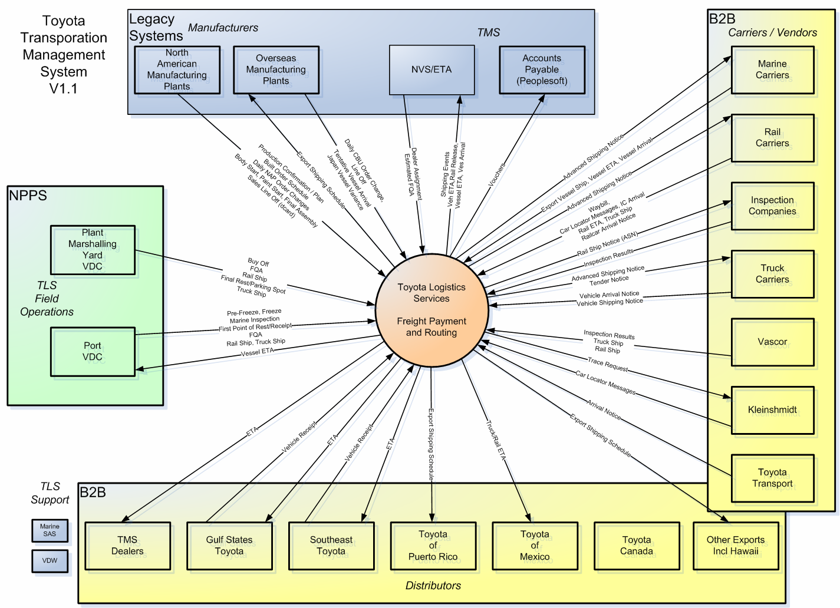

The above diagram represents the business information that is sent between the parties involved with Toyota Logistic Services FPR system. This messaging should remain the same as the system is transitioned to the COTS package. The details on how the messages are exchange may change but the transfer of information will still occur.

* 1. References
* Blueprint Website (http://blueprint)
* Toyota Reference Architecture Website (http://tv/tra)
* The Rational Unified Process: An Introduction (2nd Edition) by Philippe Kruchten
* FPR SAD from Inception Phase (FPR - Solution Architecture Document Inception – Final.doc)
* FPR SAD from Marine Elaboration Phase (FPR - Solution Architecture Document Elaboration - v2.6.doc)
* BPM X-Reference v4.xls
* Oracle Transportation Design Document for Toyota (Toyota OTM Design Document.doc)
* Oracle High Level Toyota OTM Integration Strategy (Toyota OTM integration strategy diag.vsd)

1. Architectural Representation

The architectural approach is derived from a hybrid of methodologies all based on the Rational Unified Process (RUP) as adapted by the Blueprint Process. This approach emphasizes that application architecture is developed using common and widely accepted design patterns to meet requirements and business concerns while adhering to the cardinal principles articulated in the Toyota Reference Architecture (TRA). The architecture is described first by a high-level outline, and then by a more detailed set of views each representing distinct aspects of the system from a different perspective. The last section represents another form of views, in which the architecture is revisited through each relevant systemic quality, tying the parts into the whole.

* 1. Architectural Goals and Constraints

Toyota Logistic Services has purchased a COTS product to replace the legacy home-grown Freight Payment System. The Oracle Transportation Management system will be implemented to provide the functionality required to support the planning, shipping and delivery of vehicles handled by TLS. TLS is referring to the FPR/OTM system as the Toyota Transportation Management System (TTMS).

The architectural goals of this solution are:

1. Integrate Oracle Transportation Management system (OTM), with the myriad of systems at Toyota.
2. Provide plug-and-play ability to allow for the replacement of the COTS package at a later date without a major rewrite of the integrated systems.
3. Remove the dependency on the ETA system.
4. Minimize the changes required to existing legacy systems.
5. Utilize Hyperion for reports.
6. Utilize the enterprise wide security authentication and validation framework known as the Toyota Business Gateway (TBG) framework.
7. Adhere to the guiding principles of the Toyota Reference Architecture.

Additional and specific goals and challenges of the FPR project are further addressed in five separate topics:

1. OTM COTS Integration
2. Legacy FPR System Bridging and Retirement
3. PeopleSoft Integration (Payables and Receivables)
4. Reporting from Multiple Data Sources
5. Internet-Facing B2B Integration

These are discussed in the following sub-sections.

* 1. OTM COTS Integration

The OTM application is a fully functional package that is intended to replace the home-grown FPR system. OTM provides a browser based user interface and a variety of system interfaces.

The OTM COTS package will need to be integrated with the existing legacy systems.

The name Toyota Transportation Management System (TTMS) has been introduced to represent the TLS implementation of OTM and the interfaces going into and out of the new TTMS system.

All of the former NVS FPR functionality and data will be replaced by TTMS.

This section addresses the specific interfaces to and from OTM.

**Goals**

* Limit the use and exposure of the COTS specific interfaces
* Limit the amount of data replication and redundant data storage
* Provide FPR services interfaces that will support the TLS business requirements no matter what COTS package is installed

**Constraints**

* OTM COTS Package Environment
* OTM User Interfaces
  1. Legacy FPR System Bridging and Retirement

Toyota Logistic Services has been doing Freight Payment planning, tracking, payments and integrating to the logistics operations using a combination of Legacy SAS programs and Legacy COBOL programs. These programs are all part of the National Vehicles System (NVS). The intent is to retire these programs and replace them with TTMS.

The non-FPR related NVS system will remain intact and will need to integrate with the new TTMS system.

The TTMS system will provide bridging components to supply FPR data to legacy applications. Likewise, the TTMS system will provide bridging components to provide non-FPR data to the OTM system.

**Goals**

* Minimize the changes to non-FPR applications that need access to FPR data
* Remove all FPR master data and FPR functions from NVS
* Remove redundant functionality from the NVS system

**Constraints**

* Integration to z/OS IMS and batch COBOL applications
* Integration to iSeries RPG application
  1. PeopleSoft Integration (Payables and Receivables)

Toyota Logistic Services provides payments to vendors for handling and inspecting freight shipments. There is one instance of TLS billing a party for TLS handling of the other party’s vehicles. (TLS invoices Toyota Canada for the handling of some of their vehicles.)

The TTMS system will generate vouchers that can be provided to the Finance Department PeopleSoft system for payment or invoicing TLS business partners.

**Goals**

* Use the TTMS generated payment and receivables vouchers to provide the PeopleSoft system everything needed for payment and invoice processing
* Payables and receivables should share the same interfaces when going directly to PeopleSoft
* Use the TTMS generated payment and receivables vouchers to provide the detail information to the Carriers
* Cease the use of NVS FPR payment functions and data

**Constraints**

* Only the payables currently automated in NVS will be sent directly to PeopleSoft
* Vouchers will be created for all payables and receivables but these will not be sent to PeopleSoft at this time (A Finance department initiative is underway to implement a rules-based interface that will be able to accept the TTMS Vouchers. This will allow the PeopleSoft system to process all of the TTMS vouchers without manual intervention.)
  1. Reporting from Multiple Data Sources

Toyota Logistic Services utilizes many SAS and COBOL generated reports. The SAS and COBOL programs will be replaced by Hyperion. The reports will be presented via the Hyperion and OTM web browsers.

The data sources of the operational reports will be the OTM database and the NVS databases.

The data sources for the Vehicles Data Warehouse will remain as is.

The Reporting requirements are addressed in full in a separate document. The goals and constraints listed below are addressed in the SAD.

**Goals**

* Keep no more than one copy of the data when possible
* Insulate the Report developers and the business partners from the COTS specific OTM data model

**Constraints**

* Hyperion for FPR Operational Reports
* OTM Operational Data is in Oracle
* Vehicles Operational Data is in DB2 and IMS
  1. Internet-Facing B2B Integration 

Toyota Logistic Services integrates electronically to external business partners using a variety of legacy protocols. The intent is to continue supporting the existing protocols while introduce Internet-Facing interfaces using industry standard interchange protocols and data formats.

TTMS generates information that is of interest to the Carrier and Vendor business partners that can be sent to them real-time. Examples of this are shipping notices to inspection companies, rail roads and trucking companies. Carriers and Vendors also reports information to TLS. Examples are ETA updates and equipment location updates.

TLS desires to improve the timing and quality of the B2B communication and take advantage of the Internet to do this.

**Goals**

* Provide a secure Internet-Facing gateway for the automated transmission of information to and from TLS business partners
* Provide a secure Internet-Facing user interface to allow manual access to TTMS when automated transmissions are not available or practical
* Provide tracking of data sent to/from business partners

**Constraints**

* All external TTMS access should be secured using the Toyota Business Gateway (TBG)
* All TTMS user access should be defined to PeopleSoft
* Data and feature access must be secure so Business Partners can not access data or features that are not appropriate for them
  1. Architectural Overview

The following diagram shows the design model for software and services encouraged by the TOYOTA Reference Architecture.

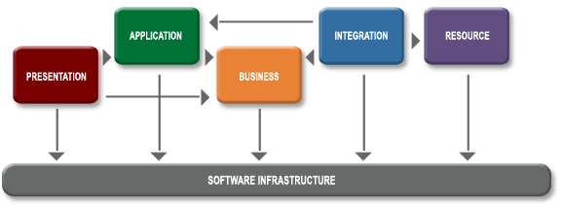

The following is a break down of the FPR Software Infrastructure into the TRA Tiers…

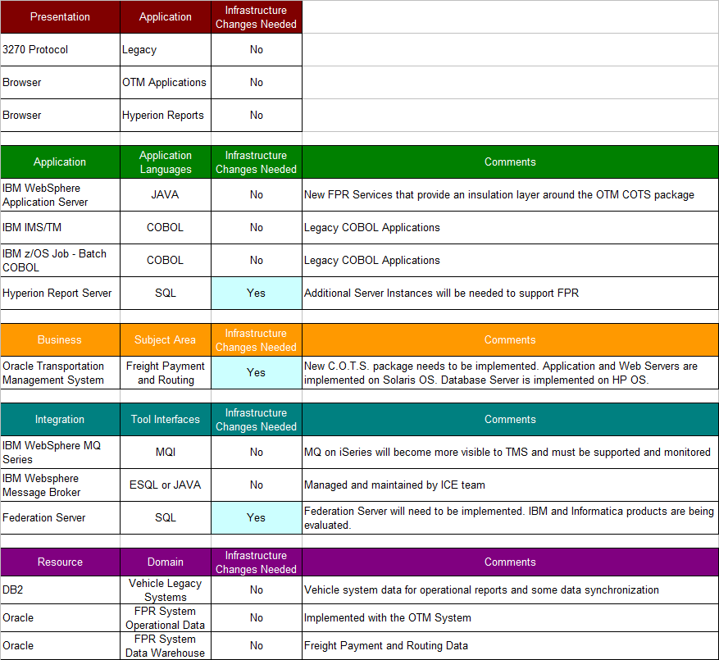

1. Architecturally Significant Use-Case View
   1. Business Process Overview

The FPR project requires significant business process reengineering to move from an import-focused two-leg supply chain to a multi-source multi-leg scalable transportation system. The figure below provides an overview of the simplified as-is business flow. The current system cannot utilize multiple modes of transportation (e.g. truck-rail-truck). Tactical challenges such as rail car and truck driver shortages and increased deviations continue to add to the instability of the logistics environment. Manual workarounds are at capacity. Any additional workarounds would not only require more staffing, but would also substantially increase the risk of errors. The number of manual workarounds is increasing with vehicle volume while the number of available transportation resourcesis decreasing. This trend is expected to continue in the future unless the system is modified to allow for increased flexibility and reduced manual intervention.



The new business process enables multiple modes of transportation (e.g. truck-rail-truck-rail-marine, etc) to ship units within a single route.



The to-be business process will provide enhanced and increased Freight Payment & Routing flexibility so the system reflects actual distribution paths and automatically pays associated charges accurately. It will reduce or eliminate most “special handling” and manual processes in favor of automated, flexible processing. The system will be configurable by the user to resolve what currently requires IT technical intervention and support.

* 1. Significant Use Cases - Overview

There are three use cases of architectural significance to this phase of the FPR project. These use cases introduce architectural patterns that will be repeated throughout the project.



The first significant use case is the SAW Create. This use case invokes an FPR function that will send data to the OTM package from a data source.

The second use case is the Order Release Create. This use case invokes an FPR function that subscribes to data published by the TMS Enterprise Service Bus.

The final use case is the Shipment Update. This use case introduces two architecturally significant system use cases. The first use case invokes a function that consumes data published real-time from the Port VDC NPPS application. (iSeries)

The second use case invokes a function that will publish data from TTMS back to the legacy systems.

The above use cases are described in more detail in the following pages..

* 1. Significant Use Cases - Details

The following use case diagrams are abbreviated realization diagrams. They depict the business use cases (in blue) and the system use cases (in yellow) that elaborate those business use cases. For one-for-one realizations (where a business use case is realized by a system use case of the same name) the business use cases are not shown in order to simplify the presentation. (i.e. for one-for-one realizations, blue represents “both business and system use case”

### SAW Create



In TTMS, Shipments represent the movement of freight from one location to another and the charges associated with shipping activity. All of the details associated with transportation activity are included on the shipment. TTMS runs processing to associate one or more shipment order releases with a single itinerary, rate, equipment type, and a service provider. TTMS then determines the route and pickup and delivery times for the shipment. Shipments statuses reflect many different aspects of shipment activity such as tendering, loading, billing, and allocation. Some statuses act as requirements for other shipment actions.

The SAW is a Shipment as Work that TTMS did not and will not plan. The shipment will simply be reported and tracked as work in progress. All Marine shipments fall into this category. The SAW is created and updated from two sources. The TMC VDLD (Vehicle Distribution and Logistics Dept) produces a CBU Order Information file that lists the vehicles scheduled to be built during the next month. These vehicles are identified by URN. The file also contains an order number (originally from TOMS), the Line Off date, the region to which the vehicle is allocated, the vessel it is scheduled to depart on, and the estimated ETD and ETA of the vessel at a US port. This event is referred to as D-6 since it is usually occurs six days before the first day of production for the month. The file contains up to 150,000 transactions daily. This is one event type of the Send Shipping Notice. Please see the Appendix A and the supplementary specification for more details on transaction volumes.

The TVA or Tentative Vessel Arrival event is the shipping manifest of a particular vessel which contains all the vehicles that are supposed to be on the vessel. For imports originating in Japan, this event is used mainly for reference purposes to provide greater accuracy on the date the vehicle can be expected on US shores. On the other hand, for vessels originating in Indonesia, and other non-Japan locations, the TVA serves as a shipping order create.

### Order Release Create



An order release in TTMS represents a single vehicle, which must be transported from its origin to its final destination (Dealer). Initially, Order Releases will be created at the legacy system PLAN event and sent to TTMS to be created with a dummy final destination representing the Region of the Dealer. Once the vehicle is allocated to a dealer an Order Release update will be sent to TTMS to update the final destination to the actual final destination. At this time the Order release will be flagged as ALLOCATED and will be included in the next OTM bulk planning cycle to create the shipments it will be on.

The Order Release Create use case introduces the first FPR function that uses data published by the ESB. The real-time Vehicle Inventory Change service publishes all events that occur during the life cycle of the vehicle up until the point when the vehicle retails. The dealer assignment event will be sourced from this existing service. The assigned dealer is typically the final destination for any FPR shipment. As the dealer assignment changes the FPR system will be notified so shipping orders can be updated accordingly.

### Shipment Update



Shipment updates can come from three business entities: the shipping company, the truck and rail companies and the vehicle distribution centers (VDCs). The NPPS system captures, processes, and propagates many of these updates. The Vehicle Distribution Center is a location where vehicles are processed and sent to dealerships, regions, or customer locations. VDCs include marshalling yards, which are locations next to North American Assembly plants where vehicles are consolidated, processed and sent to final destinations.

VDC can also be ports, where the vehicles arrive by vessel, then consolidated, processed, and shipped to final destinations. Ports are a link between manufacturing plants and the customer. Their operations include:

* Marine Planning and Vehicle Discharge
* Production scheduling based on Allocations
* Installation of Post-Production Options
* Final Quality Assurance inspections
* Truck away Transportation to Dealerships
* Rail loading and transportation to railheads
* Kaizen Department - reduce muda
* Quality Department – improve customer satisfaction
* Environmental Health & Safety management system

The significant business events for this system use case are listed below:

1. **Estimated FQA –** This date is used by TTMS to plan the start date of shipments to the dealers. Estimated FQA is updated anytime between production confirmation and final quality assurance.
2. **Pre-freeze -** It is a ‘heads-up’ event that indicates that the final destination is going to be locked in the near future (typically 2-3 days). For domestics, this can happen anytime during the building of the car, for imports this happens three days before the vessel arrives at US ports
3. **Freeze –** This is the event that indicates that the final destination of the vehicle is ‘locked-in’ and will not be changed. This vehicle event allows TTMS to start planning out the route and the itinerary of the vehicle.
4. **First point of rest –** This is the location where the vehicles are parked after inspection. A Monroney label is placed on the vehicle and this is before the vehicle is tendered to either truck or rail.

After the shipment is updated on TTMS the shipment plan and changes are published to interested subscribers. This is the mechanism that TTMS will use to send data back to the legacy systems.

1. Solution Overview
   1. As Is

The current FPR system is implemented using a combination of COBOL programs and the SAS programs. All operational data is accessed via 3270 mainframe screens.

The following diagram gives an overview of the current FPR application as it is today.



* 1. To Be

The future FPR system will be implemented using the OTM COTS package. Data will be fed to OTM from multiple sources via MQ and the TMS ESB. A java layer will be introduced on z/OS to insulate TMS applications from the OTM COTS specifics.

The following diagram gives an overview of the FPR application with the OTM COTS integration.



* 1. TTMS Integration

Integration to and from the TTMS system is the primary architectural issue for the FPR project. There are old and new sources of Freight Payment data that will need to provide the data to TTMS. The TTMS system will also publish relevant events that will need to be consumed by other applications.

The following diagram provides an overview of interface messages being provided to TTMS and messages being published from TTMS.



The TTMS rectangle at the bottom of the diagram represents the OTM abstraction layer. All integration to OTM will occur through this layer.

The rectangles at the top of the diagram represent the peer systems. The ovals represent the integration use case patterns. The dark filled ovals represent integration out of TTMS. All of the white filled ovals represent integration to TTMS. The text on the arrows between the systems and the integration use cases represents the different messages that flow between the systems. The messages highlighted in blue represent the messages addressed by this phase of the project.

The grey cylinder in the middle of the diagram represents the system integration layer. There can be point to point integrations or peer agnostic integrations. Enterprise services may be implemented via the ESB.

The color coding on the message flows represent a release based implementation view of the integration points. The ovals on each flow represent service candidates which ICE will provide a Service Litmus Test evaluation.

Data being provided from one system to another system requires an agreement from both applications on the data format and the data transport mechanism. In this document this scenario is considered a point to point integration.

Data being published to subscribers requires an additional application to mediate the integration. In this document this scenario is considered an abstract integration. The provider does not need to be aware of the consumers and the consumer does not need to be aware of the provider. The integration layer will mediate the integration and transform both the data formats and transport protocols appropriately.

* 1. TTMS Interfaces

The following tables represent the interface messages that are relevant to the project. The messages are grouped by the interface source and the vehicle event to which they belong. Each one of these vehicle events are represented in more detail in the following pages. The architecture patterns for each event type are represented in section 13.3 and mapped in section 13.4.

The tables are grouped as follows:

* Interface Events relevant to this phase
* External B2B FPR Events
* VDC FPR Events (plants and ports)
* VDC Plant Events (plants only)
* VDC Port Events (ports only)
* Vehicle Inventory Change Notify Events
* FPR Publish Events

All of the interfaces will go to the legacy system via the TTMS Inbound and Outbound Solution. The B2B Interfaces that will be upgraded to use the Internet Facing B2B have not been determined.

All of the interface events will be further scrutinized during the TRE design and B2B Release.

### Summary of Interface Events and Rationale Relevant to this phase

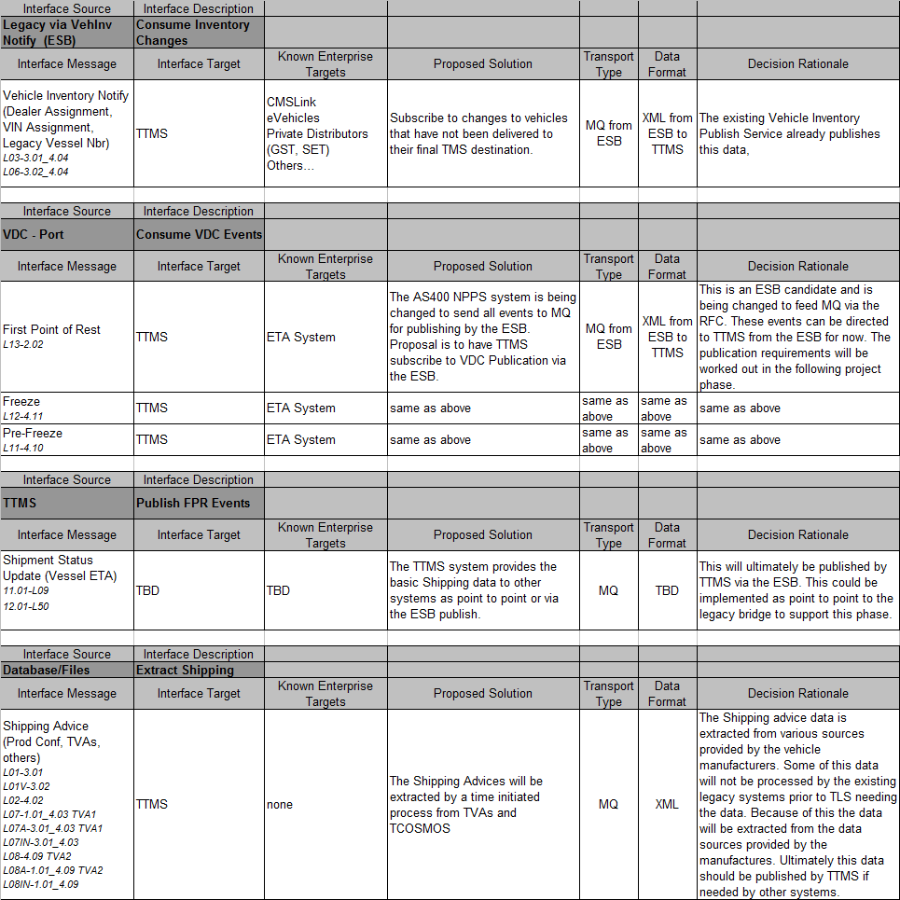

* The *italicized* codes in the Interface Message cell align with the OTM Interface Strategy Document.

### External B2B FPR Events

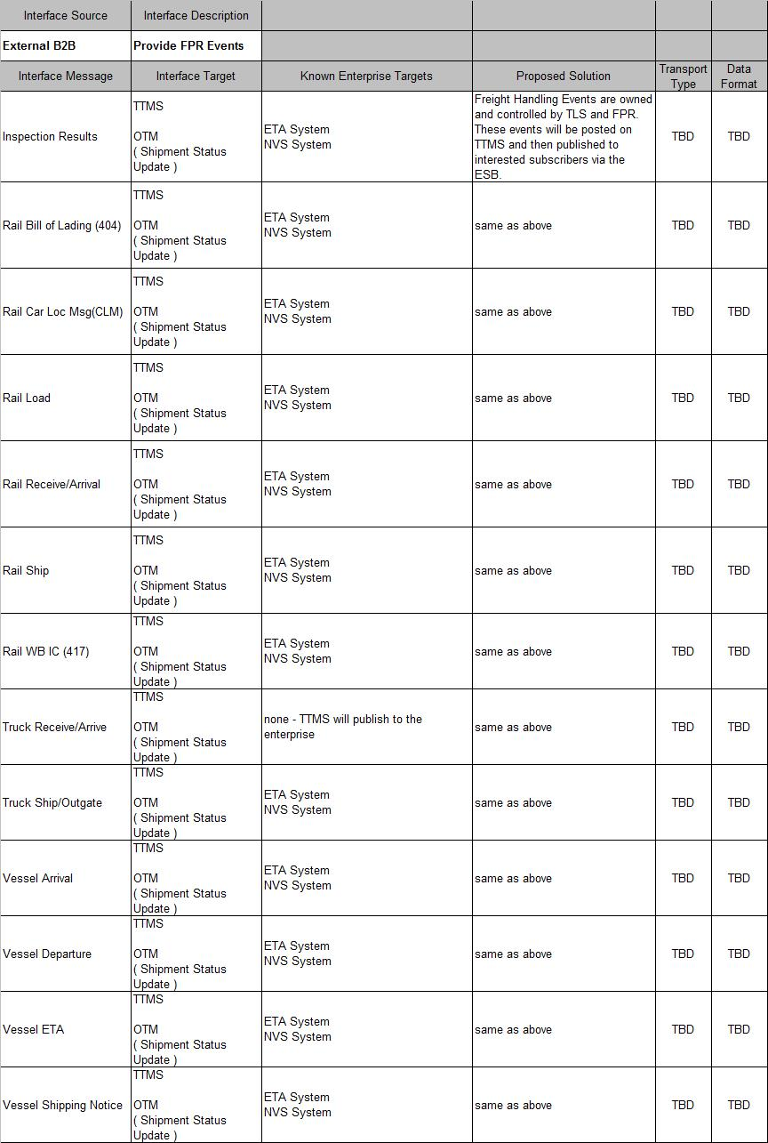

### VDC FPR Events (plants and ports)

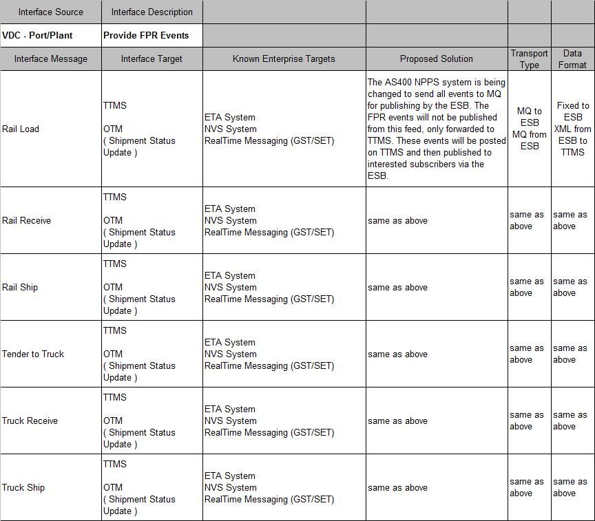

### VDC Plant Events (plants only)

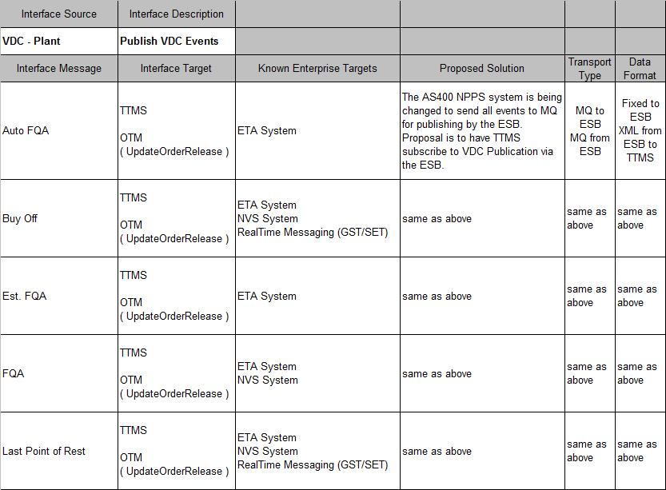

### VDC Port Events (ports only)

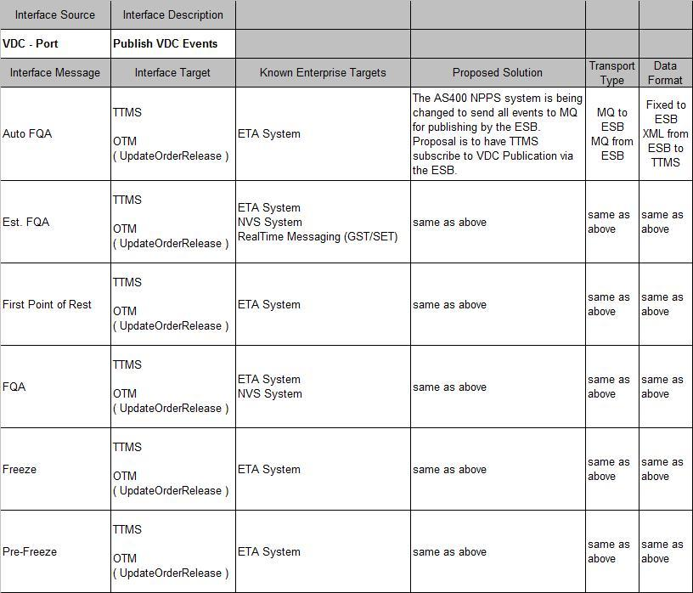

### Vehicle Inventory Change Notify Events

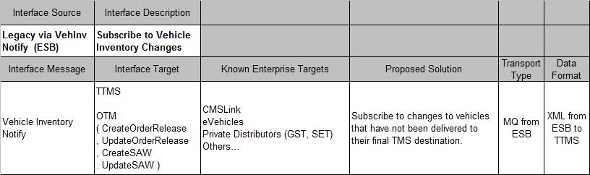

### FPR Publish Events

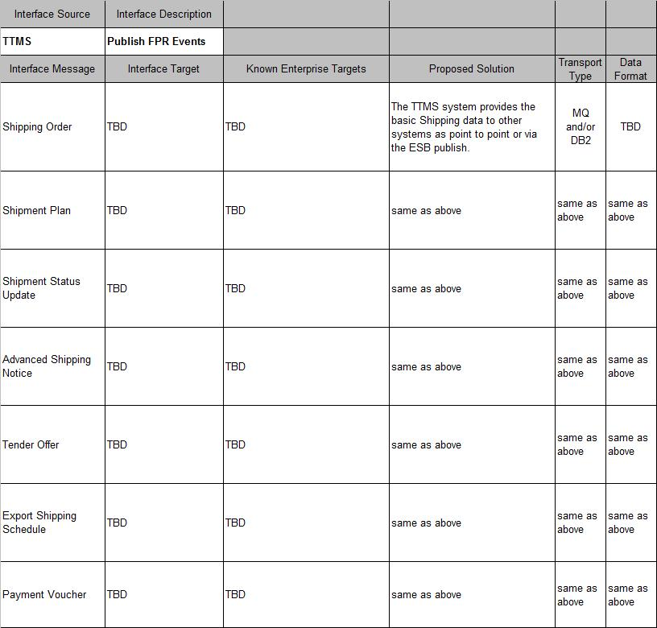

* 1. Solution Details

### OTM COTS Integration

The OTM COTS Integration solution starts with an abstraction layer that encapsulates OTM.

The inward facing side of the abstraction layer will be tightly coupled to the OTM specific protocol and schema.

The outward facing side of the abstraction layer will expose a façade that is made up of TMS FPR operations, entities and attributes. The interface protocol exposed to the outward facing side will be compatible with COBOL and JAVA.

All applications or services will communicate with abstraction layer and NOT directly with OTM. This will insulate TMS applications from the complexities of the COTS specific schemas and interface requirements. For the remainder of this document the abstraction layer in combination with OTM will be referred to as TTMS (Toyota Transportation Management System).



The TTMS abstraction layer will provide the following functionality:

* Persistence and guaranteed delivery
* Transaction Management
* Time Independence between the legacy systems and OTM
* Isolation of the complex OTM Schema
* Isolation of the OTM interface protocol
* COTS specific data aggregation
* Business Rules and Application Logic

TTMS Abstraction Layer design will be referenced later in this chapter in Interface Patterns 1, 2, 3 and 4. The framework for the abstraction layer and all of the OTM interactions were validated in a prototype. See the TTMS Framework documentation for the details of the framework and the prototype.

The main integration scenarios handled by the abstraction layer include:

* TTMS Inbound
* TTMS Outbound

**TTMS Inbound**

TTMS will provide an MQ inbound endpoint type that can be used by peer application systems. The preferred data format for message content will be defined in the TTMS message schema. This schema has not been yet developed.

More than one MQ Endpoint might be implemented to support messages of different data domains. Each MQ endpoint or queue will drive its own instance of a MDB in the TTMS Java framework. See the TTMS JAVA Framework documentation for more details on the MDB.



TTMS Inbound design will be demonstrated later in this section in Interface Patterns 1, 2 and 3.

**TTMS Outbound**

TTMS will provide outbound data via MQ and DB2. Some of the data being published by TTMS will be persisted in DB2 tables. The assumption is that all data published will be persisted, but this has yet to be validated. As with the inbound data the preferred data format for message content will be defined in the TTMS message schema. This schema has not been yet developed.

The data written to MQ and DB2 will be persisted in the same transaction prior to the HTTP post response to OTM.

In addition to the TTMS interface the OTM COTS package itself may send email directly to the TMS email server.



TTMS Outbound design will be demonstrated later in this section in Interface Pattern 4.

**Decision Rationale**

The following table represents the primary architectural decisions made with this solution along with the rationale behind the decisions.

|  |  |  |  |
| --- | --- | --- | --- |
|  | Decision | Options considered | Rationale |
| 1 | Create Abstract Layer | 1) Create Abstract Layer  2) Have all peer applications interface directly to OTM | a. OTM message schema is complicated and very large due to the generic nature of the COTS application. An abstract layer insulates applications from the complexity and exposes a simpler TLS schema.  b. OTM requires aggregation, validation and other business logic prior to sending data to the OTM interface. An abstract layer insulates applications from the COTS specific business logic.  c. The OTM interface uses limited protocols that are not easily implemented using COBOL. The abstract layer can provide the bridge between legacy protocols and the OTM protocols. |
| 2 | JAVA | 1) JAVA  2) WMB | a. The abstract layer introduces a tightly coupled point to point integration with OTM. The services used to implement the abstract layer need to reference COTS specific data on DB2 and Oracle DB for validation and aggregation. Business logic is also applied to manage the data sent to OTM and received from OTM. ESB Reference Architectures recommends NOT having business logic, state management and database persistence in the WMB/ESB. |

**Decision Rationale continued**

|  |  |  |  |
| --- | --- | --- | --- |
| 3 | WAS | 1) WAS  2) WLS | a. The OTM integration services and the TTMS framework will be implemented as two basic services. A service to format and send data to OTM and a service to format and publish data out of OTM. There should be little or no growth in the functionality unless the COTS package itself is changed extensively. The TMS D&E infrastructure team (UNIX and Mainframe) agreed to deploy the services on the existing WAS z/OS servers rather than introducing additional distributed hardware to support this limited application. (i.e. Additional Weblogic servers would need to be procured.) |

### TTMS/OTM Abstract Layer Framework

The TTMS/OTM Abstract Layer was designed and tested on WAS z/OS. The following pages give a more detailed overview of the framework.

**Overview**

The OTM Invocation for FPR gathers information about a URN and submits it to the OTM. The diagram below illustrates a high-level view of the components involved.

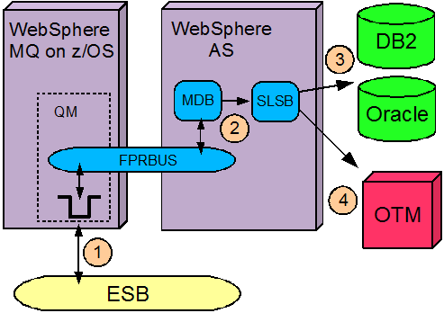

The execution flow proceeds as follows. The step numbers correspond to the numbers in the diagram.

1. The ESB forwards an FPR OTM request to a designated WebSphere MQ queue on z/OS.

2. The presence of the message on the queue triggers the execution of a MDB which handles the interpretation of the input message. The MDB delegates to a SLSB which obtains configuration information from JNDI and provides for concurrency and transaction management.

3. The VEHCNTL.TCOSMOS table is queried for information pertinent to the OTM invocation. The query result is transformed to the OTM XML schema.

4. OTM is invoked via HTTP POST with the XML.

**Code**

The following diagram illustrates the component organization within the application.

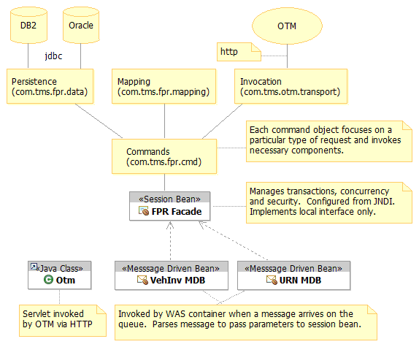

The Javadoc elaborates on this diagram, the code and it’s API. A snapshot of the maintenance guide is available in PDF format.

**JNDI**

Here is the current JNDI tree structure in use by FPR.

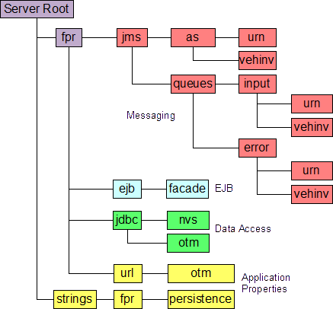

**WebSphere MQ on Distributed Platforms**

A slightly different SI bus topology is required for test environments that work only with MQ on distributed platforms. (i.e. not the mainframe) Distributed MQ queue managers can not be made bus members of the SIB. Instead, they have to be configured as a foreign bus and connected via an MQ Link. A local SIB queue is created for the input message and is configured as a remote queue on the Websphere MQ side. The flow for this topology is illustrated below.

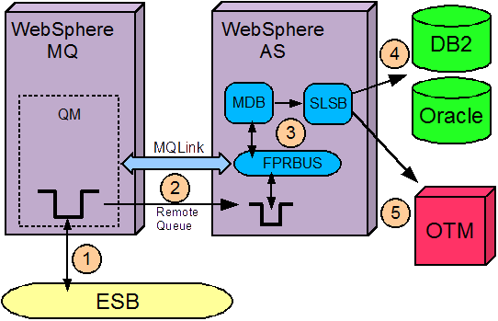

1. The ESB forwards an FPR OTM request to a designated WebSphere MQ queue.
2. The MQ Link between the QM forwards the message via the remote queue definition to the WAS queue via its SIB.
3. The presence of a message on the WAS queue triggers the execution of a MDB which handles the interpretation of the input message. The MDB delegates to a SLSB which obtains configuration information from JNDI and provides for concurrency and transaction management.
4. The VEHCNTL.TCOSMOS table is queried for information pertinent to the OTM invocation. The query result is transformed to the OTM XML schema.
5. The OTM is invoked via HTTP POST with the XML.

**Sample Interaction with the TTMS Abstract Layer**

The TTMS Abstract layer is shown in the orange TTMS rectangle in the following diagram. This sample shows how data can be fed to TTMS from multiple sources via MQ.

This section is intended to be a sample scenario. The design may change.

TTMS will expose an interface that will allow providers to send advanced shipping orders and updates the orders via an MQ queue. The TTMS Abstraction layer will handle the COTS nuances.



## 

### Legacy FPR System Bridging and Retirement (Marine Only)

All of the functionality of the legacy marine system will be provided by OTM. There are 4 primary aspects of the Legacy System retirement effort.

1. Providing the marine data inputs to TTMS
2. Providing TTMS processed marine data outputs to legacy applications (Legacy Bridging)
3. Removal of retired applications
4. Removal of data artifacts

**Providing the marine data to TTMS**

The data provided to support marine is made up of three basic types. Master data, Marine shipment data and vessel in transit status updates. TTMS will become the master source for the Marine master data and all shipment information. The Marine shipment data will be created from existing data sources that are directly available to TTMS. This data will either be read directly by TTMS or published to TTMS via the ESB. status updates/events are driven from the NPPS systems

There is no need to change any legacy COBOL code to provide data to TTMS.

**Providing TTMS marine data to legacy applications (Legacy Bridging)**

TTMS will publish Marine data to MQ and/or DB2. The data will be persisted and committed in the same unit of work. The shipment data will be written to MQ so that the vessel information and ETA data can be written to a sequential file and processed the same way that it is today.

The shipment data will be written to DB2 along with shipment status updates. This includes the Vessel ETA and Vehicles on the Vessel.



### Legacy FPR System Retirement (non-Marine)

The following is a summary of the artifacts to be retired during the TRE Release.

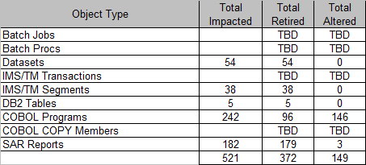

NO infrastructure components will be retired as part of the FPR project.

The TRE System integration team will be defining the actual retirement strategy.

### Accounts Payable Integration

The accounts payable vouchers will be sent to the mainframe using the TTMS Outbound interface. The actual interface from the mainframe to the AP system will remain as is.



### B2B integration

The TRE implementation of the B2B Interface will use the existing mainframe B2B infrastructure. The files that feed or are sourced from the existing B2B infrastructure will be bridged as documented in the TTMS Inbound and Outbound Interfaces.

The internet facing B2B solution will be introduced in the B2B Phase.



### Reporting from multiple data sources

Operational Reporting will be provided through the OTM User Interface and through Hyperion. Federation will be used, once available in Production, and as appropriate for Operational Reporting (Arch Pattern #8). These Operational Reports will be pulled directly from OTM and other required Production applications. This has no direct impact to the COBOL or JAVA application code.

OTM data will also be passed into the VDW through Arch Pattern number 8 for Analytical purposes. At this time, no requirements have been identified for the creation of a new datamart.



* 1. Integration Patterns

### Pattern 1: Extract and Send DB2 Data to TTMS (Example: SAW Create)

The SAW Create use case is an example in which TTMS consumes data directly from a provider. This is considered a point to point integration. The applications that source this data will provide the Marine Shipment plan via a message.

The message will be read by the TTMS Interface application, formatted to the specific OTM format and sent to OTM via the OTM specific protocol requirements.



**1**

**2**

**3**

**4**

**5**

Like any COTS package the OTM system has its share of nuances. For example, the OTM system relies on generated ids to reference objects in the system. These ids will not be known to existing applications.

To isolate the COTS specific nuances from other applications at TMS the TTMS integration layer will provide an abstract interface. This interface will expose standard FPR services based on TMS business functions. It will hide the specifics of the COTS interface from the rest of TMS.

**Chronology of Events:**

1. **Read Source Data:** CBU PROCON, TVA, and shipping notices are read from a database (most probably DB2).
2. **Format SAW and Publish Message:** The message is formatted appropriately and published on an MQ queue.
3. **Consume SAW:** The FPR Integration Layer consumes the SAW event.
4. **Data Aggregation:** OTM specific order and message marshalling data is read and the incoming SAW message is enriched.
5. **HTTP Post:** The enriched message is then published to OTM via HTTP.

### Pattern 2: ESB Publishes data to TTMS (Example: Order Release Create)

The Order Release Create use case is an example in which TTMS consumes data from the ESB. The NVS publishes vehicle inventory changes and TTMS will subscribe to those changes. This is considered to be an abstract integration in that the consumer applications are not aware of the provider data format or data transport protocol.

The message will be read by the TTMS Interface application, formatted to the specific OTM format and sent to OTM via the OTM specific protocol requirements. 

**1**

**2**

**3**

**5**

**6**

**4**

**Chronology of Events:**

1. **Publish Production Confirmation:** NAP production confirmation (PROCON) is sourced and published as a copybook on to the ESB.
2. **ESB Mediation:** The ESB reads the message and transforms the message from Copybook to XML and then publishes it to interested parties over multiple platforms. The ESB interaction pattern that is utilized to support this requirement is publish/subscribe. If enrichment of the message published to TTMS is necessary, the ESB Broker Pattern working in conjunction with the Synchronous Request-Reply pattern to invoke a data service that provides the data to enrich the message can be utilized
3. **Consume Order Release:** The FPR Integration Layer consumes the order release event.
4. **Data Aggregation:** OTM specific order and message marshalling data is read and the incoming order release message is enriched.
5. **HTTP Post:** The enriched message is then published to OTM via HTTP.
6. **Other Interested Systems:** The event can be published to other interested subscribers.

### Pattern 3: NPPS System feeds data to TTMS (Example: Shipment Update)

The Shipment Update use case is an example in which TTMS consumes shipment status information. The NPPS plant and port systems publish event information that is used in the shipments. TTMS is a subscriber to VDC event data and will be notified via a MQ message when the VDC events are published.

The message will be read by the TTMS Interface application, formatted to the specific OTM format and sent to OTM via the OTM specific protocol requirements.



**1**

**2**

**3**

**5**

**6**

**Chronology of Events:**

1. **Publish VDC Event:** VDC events are sourced and published as a copybook on to the ESB.
2. **ESB Mediation:** The ESB reads the message and transforms the message from Copybook to XML and then publishes it to interested parties over multiple platforms. The ESB interaction pattern that facilitates this interaction is the publish/subscribe pattern.
3. **Consume VDC Events:** The FPR Integration Layer consumes the order release event.
4. **Data Aggregation:** OTM specific order and message marshalling data is read and the incoming order release message is enriched.
5. **HTTP Post:** The enriched message is then published to OTM via HTTP.
6. **Other Interested Systems:** The event can be published to other interested subscribers.

### Pattern 4: TTMS feeds data to Legacy systems (Example: Shipment Publish)

The Shipment Publish use case is an example in which TTMS will publish data to the legacy COBOL system. As Shipment Plans are generated, TTMS will store the plan in DB2 and publish it to the ESB. The ESB will format and publish the shipment plan to interested providers. In this use case one of the subscribers is a program that will act as a legacy bridge. The legacy bridge will format and store data into an IMS segment used by applications with interest in the shipment plan.

**2**

**1**

**1**

**3**

**4**

**5**

**6**

**7**



**Chronology of Events:**

**5**

**4**

**3**

**1**

**6**

1. **Provide Shipment Update:** The FPR Integration Layer extracts shipment updates, persists it in DB2 and publishes it on the ESB.
2. **ESB Mediation:** The ESB reads the message and transforms the message from XML to a CMM and then publishes it to interested parties over multiple platforms.
3. **Consume Shipment Update:** The ESB transform the XML message to a copybook and publishes it to an MQ queue from where it is picked up by a legacy bridge.
4. **Publish Shipment Update:** The shipment update is published as a copybook.
5. **IMS Segment:** The relevant IMS segments are updated.
6. **Legacy COBOL:** Existing COBOL programs that depend on shipment updates can continue to read the information from the IMS segments as before.
7. **Other Interested Systems:** The event can be published to other interested subscribers.

1. Use Case Realizations

Following section shows how the software actually works by giving a few selected use-case (or scenario) realizations.

* 1. Realization 1: SAW Create – Feeds data to TTMS

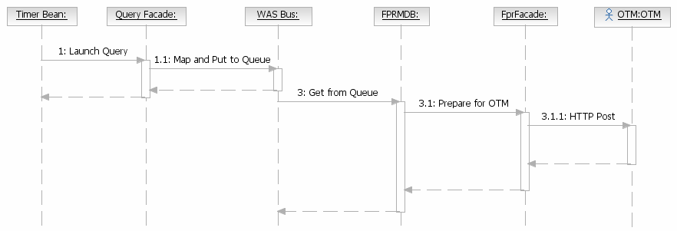

|  |  |
| --- | --- |
| Transaction One |  |
| Operation | Description |
| Launch Query | Timer bean triggers at a set time daily and launches the query façade. |
| Map and Put to Queue | The query façade is a stateless session bean that executes a query to find all of the shipping orders ready to be sent to TTMS.  The data is formatted and written to an MQ queue via the WAS SI Bus. |
|  |  |
| Transaction Two |  |
| Operation | Description |
| Get from Queue | The FPRMDB is triggered by the WAS SI bus when the message arrives on the queue. |
| Prepare for OTM | The FPRMDB will trigger the FPR Façade to format and prepare the data for OTM. |
| HTTP Post | The FPR Façade will post the message to OTM and commit the transaction on a successful response from the post. |

* 1. Realization 2: Order Release Create – ESB Publishes data to TTMS

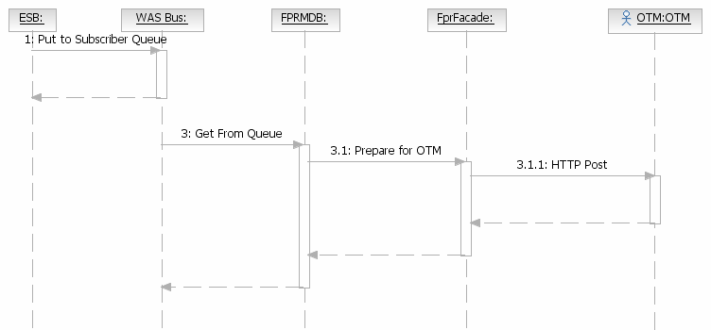

|  |  |
| --- | --- |
| Transaction One |  |
| Operation | Description |
| Put to Subscriber Queue | The ESB publishes the production confirmation data. TTMS is a subscriber of this data.  The data is formatted and written to an MQ queue. |
|  |  |
| Transaction Two |  |
| Operation | Description |
| Get from Queue | The FPRMDB is triggered by the WAS SI bus when the message arrives on the queue. |
| Prepare for OTM | The FPRMDB will trigger the FPR Façade to format and prepare the data for OTM. |
| HTTP Post | The FPR Façade will post the message to OTM and commit the transaction on a successful response from the post. |

* 1. Realization 3: Shipment Update – NPPS System feeds data to TTMS

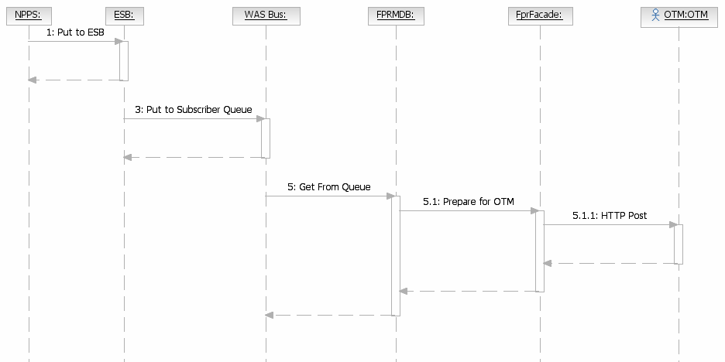

|  |  |
| --- | --- |
| Transaction One |  |
| Operation | Description |
| Put to ESB Queue | The NVS provides all VDC events to the ESB via MQ. |
|  |  |
| Transaction Two |  |
| Operation | Description |
| Put to Subscriber Queue | The ESB publishes the production confirmation data. TTMS is a subscriber of this data.  The data is formatted and written to an MQ queue. |
|  |  |
| Transaction Three |  |
| Operation | Description |
| Get from Queue | The FPRMDB is triggered by the WAS SI bus when the message arrives on the queue. |
| Prepare for OTM | The FPRMDB will trigger the FPR Façade n and prepare the data for OTM. |
| HTTP Post | The FPR Façade will post the message to OTM and commit the transaction on a successful response from the post. |

* 1. Realization 4: Shipment Publish – TTMS feeds data to Legacy systems

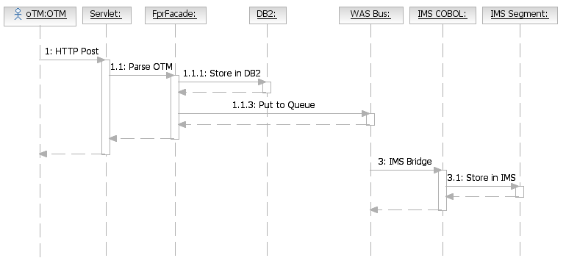

|  |  |
| --- | --- |
| Transaction One |  |
| Operation | Description |
| HTTP Post | OTM sends data that it publishes to the Legacy system via an HTTP Post to a Java Servlet. |
| Parse OTM | The Java Servlet launches the FPR Façade to parse the data, store the data in DB2 and send the data to the legacy bridge. |
|  |  |
| Transaction Two |  |
| Operation | Description |
| IMS Bridge | MQ Provides a bridge to IMS programs that allows IMS MPPs to be executed without the knowledge of the MQ source. The IMS programs are triggered by IMS with messages in the inbound IMS queue. |
| Store in IMS | The COBOL program will enhance the data as needed and store it in the legacy IMS table. |

1. ESB Interaction Patterns

The common ESB interaction patterns that have been referred in the FPR patterns section above are detailed below

|  |  |  |  |
| --- | --- | --- | --- |
| **Architectural Pattern** | **State in Caller** | **State in Called** | **Synchronization** |
| Publish-Subscribe | No | Yes | Asynchronous |
| Synchronous Request-Reply | Yes | No | Synchronous |
| Asynchronous Query Pattern | Yes | No | Asynchronous |
| One-way notification | No | No | Asynchronous |
| ESB Broker Pattern | No | No | Synchronous |

* 2. *Publish-Subscrib**e*

Applications that communicate through publish and subscribe paradigm require the sending applications (publishers) to publish messages without explicitly specifying recipients or having knowledge of intended recipients. Similarly, receiving applications (subscribers) must receive only those messages that the subscriber has registered an interest in. This form of asynchronous messaging is a scalable architecture, since message senders need only concern themselves with creating the original message, and can leave the task of servicing recipients to the messaging infrastructure.

A subscriber subscribes to a queue by expressing interest in messages posted to that queue and by using a subject- or content-based rule as a filter. This result in a set of rule-based subscriptions associated with a given queue. At runtime, publishers post messages to various queues. The queue then delivers messages that match the various subscriptions to the appropriate subscribers.

The decoupling between senders and recipients is accomplished by the Enterprise Service Bus which resides between the publisher and the subscriber and delivers the message to the appropriate subscribers based on the subscriptions.

The following [figure](http://www.utexas.edu/its/unix/reference/oracledocs/v92/B10501_01/appdev.920/a96590/adg15pub.htm#998770) illustrates publish and subscribe functionality.

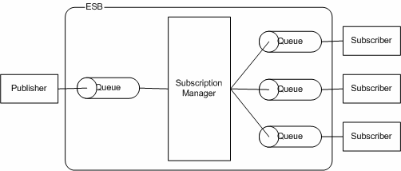

Publish-Subscribe Interaction Pattern

* 1. *Synchronous Request-Reply*

In the synchronous request-reply pattern, when an application sends a message, it expects to receive a message in return. This pattern can be used when one or more senders need to send messages to a single receiver. At TMS, this pattern will be realized as a HTTP service, where the message format can be either XML or SOAP (or possibly Cobol copybook).In this implementation, the request is addressed to a specific service provider, which processes the message and responds as part of the same call.

Decoupling is achieved by making the request to the mediator (ESB in this case) which forwards the request to the service provider. The service provider endpoint might be either synchronous or asynchronous. If the provider endpoint is asynchronous, a protocol translator building block is used. In addition to providing an indirection layer, the mediator performs data transformation to meet the service provider’s format.

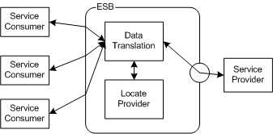

**Synchronous Request-Reply Interaction Pattern**

This interaction pattern is applicable when near real-time response is required and the processing times to process messages are small.

* 1. *Asynchronous Query Pattern*

In this pattern, an application sends a request to a target application and then continues its own processing, while the target application handles the request independently. The sender does not have to wait either for the remote processing to complete, or for a reply to come back. Instead, the thread sends the message and continues processing client requests. The target application need not even be “up and running” at the time the sender sends the request. When using asynchronous communication, applications are loosely coupled. The requesting application is not bound to the responding application, or to the communication delivery mechanism.

The interaction between the components is shown in the following diagram:

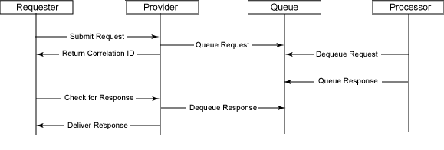

Asynchronous Query Pattern

This pattern is realized using WebSphere MQ. The reply queue can be specified in JMS and MQ “replyToQueue” option, or by defining the replyQueue in the Endpoint.

The sender can check for a response (polling), or be notified of the response. In either case, a Correlation Identifier should be used to match the response to the request. A third option, waiting for a response, is an anti-pattern as the thread in the receiver thread is holding up resources , and should generally be avoided as it defeats the purpose of the async query pattern.

This pattern is applicable only when one or more senders need to send messages to a single receiver asynchronously, and a response is expected.

* 1. *One-way Notification*

The one-way notification pattern is similar to the asynchronous query pattern except that the receiver is not expected to reply to the message. An application sends the message and does not expect a response for the message.

This pattern is used when one or more senders need to send messages to a single receiver. This is different from publish-subscribe where there are multiple receivers for a single message. The sender and receiver are decoupled by the queuing mechanism, which handles the reliable delivery of messages to the receiver.

The TMS variation of this pattern is that the sender is notified of application errors by the receiver. The error response is sent to the “replyToQueue”.

This pattern is applicable when one or more senders need to send messages to a single receiver asynchronously, and a response is not expected (except in the case of errors).

* 1. *ESB Broker Pattern*

In addition to using the ESB as a router (along with mediation), the ESB Broker pattern allows service invocations to be encapsulated behind a single request to the ESB from a service client. The ESB will make a service request to each of several providers for different services, aggregate the responses, and return the results to the consumer.

1. Deployment View

The deployment view represents the relationships between the deployable packages and their physical nodes.

* 1. Overview

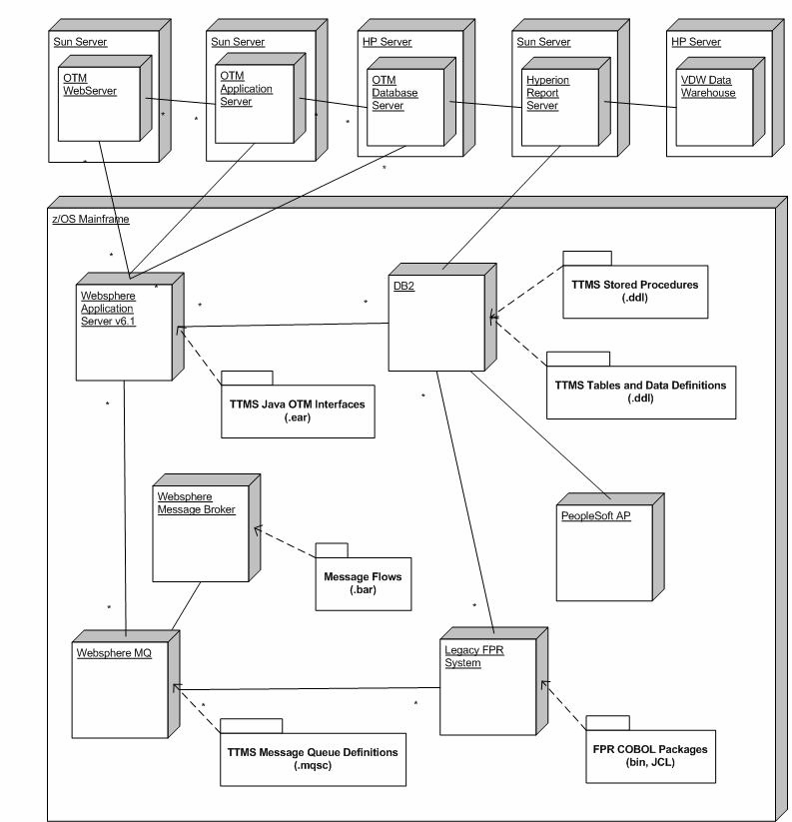

* 1. Nodes/Servers

The nodes and servers that are relevant to this project are listed in the below.

|  |  |
| --- | --- |
| Node | Server |
| Sun | Apache Web Server |
| Sun | WebLogic Application Server |
| HP | Oracle DBMS |
| Mainframe | WebSphere Application Server |
| Mainframe | DB2 DBMS |
| Mainframe | WebSphere MQ Server |
| Mainframe | z/OS Batch, ,IMS, CICS |

* 1. Deployable Packages

The deployable artifacts that will be handled during the construction of this project are listed below. These artifacts will be used to deploy and configure the system.

|  |  |
| --- | --- |
| Deployable Artifacts | Artifact Type |
| JAVA OTM Interfaces | ear files |
| Database DDL | ddl scripts |
| Database Stored Procedures | ddl scripts |
| Message Queue Definitions | mqsc scripts |
| COBOL Applications | binaries |

* 1. Connectivity

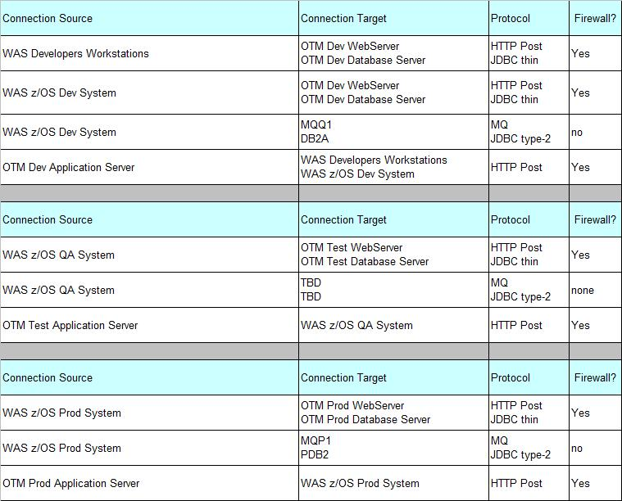**Software list**

The applicable software that will be used during the construction of this project is listed below.

|  |  |  |  |
| --- | --- | --- | --- |
| Itemize | Tool Name/Description | Purpose | Frequency of Use |
| 1 | Clarity | Resource time tracking | No less than weekly |
| 2 | ClearCase | Store all documentation and source code, except mainframe | As required by TMS/USA Project Manager |
| 3 | ClearQuest | Defect tracking application | As required by TMS/USA Project Manager |
| 4 | Lotus Notes | Communication and scheduling | As required by TMS/USA Project Manager |
| 5 | Microsoft Office Suite | Documentation | As required by TMS/USA Project Manager |
| 6 | Rational Software Architect (RSA) | Design artifact for J2EE | As required by TMS/USA |
| 7 | Rational Application Developer (RAD) | For Java programmer IDE | As required by TMS/USA |
| 8 | Visio | Designing diagram/documentation | As required by TMS/USA |
| 9 | ErWin | Data modeling tool | As required by TMS/USA |
| 10 | Development and unit test tools to be named | Development and unit testing | As required by TMS/USA Project Manager |

1. Security

All user access to the OTM system will be through the OTM Browser interface. User identification and authentication will be handled by the Toyota Enterprises Security System (TESS) framework. Once the user has been granted access to the OTM interface the UI will be dynamically presented using the OTM role based configuration policies.

User identification will be owned and managed by TESS and the Identity record of reference. The OTM roles will be managed on the OTM system.

*Security for the electronic B2B interfaces is not applicable during this phase of the project and is therefore not addressed in this version of the SAD.*

The mainframe infrastructure components are already in place and managed by RACF. No additional security is required for the mainframe components.

* 1. TESS Strategy - OTM

Figure 1-TESS-OTM (COTS) Strategy

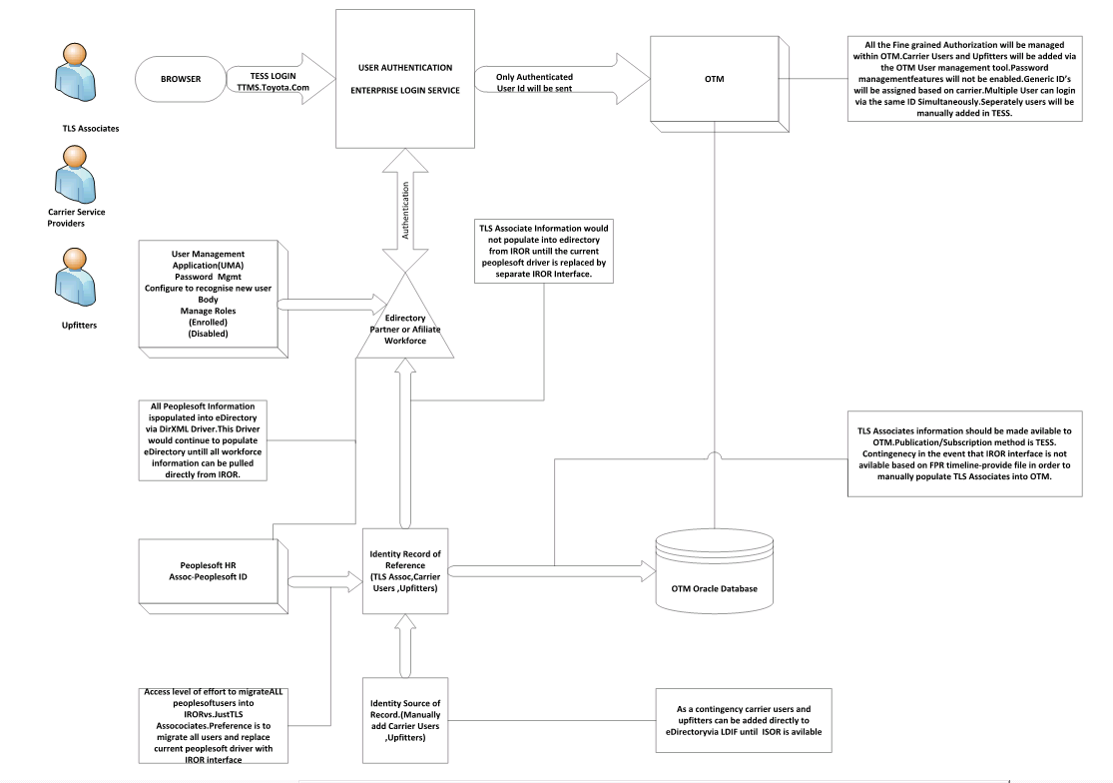

* 1. Authentication and Authorization - DRS

### SSO Domains

Single sign on will be available between DRS and other corporate applications in same domain (toyota.com). These are same set of applications that have Single Sign on with TV. (The user should have authorized access for both applications).

Timeouts – Max Session and Idle

The max session and idle session timeout will be governed by the active application on the browser at that time and will be mapped w.r.t the ObSSOCookie Cookie login timestamp value.

### Authentication

Authentication in TTMS DRS is handled by TESS. When user enters his details in the TESS Login screen, the provided information is validated against TESS and User ID, Hex GUID and Roles are sent in response. Application will catch the response and convert the incoming data in application useful objects.

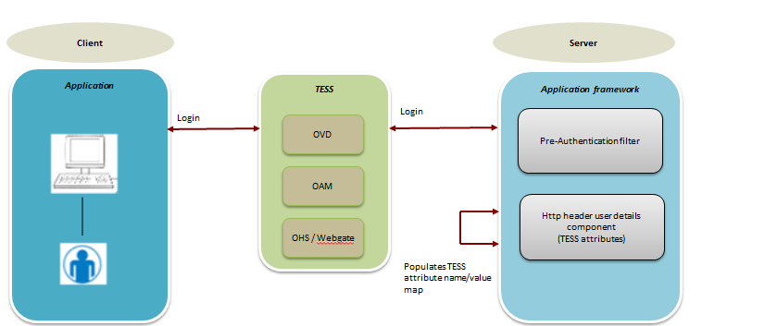

### Authorization

TESS will do coarse grained authorization based on the enrolled status of the user for DRS application. Fine grained authorization is handled within the application.

Authorization is done through fine grained roles in which the incoming User ID is checked in OTM end and access is granted.

### Users Enrollment

Users can be enrolled to the application using the following options:

Toyota user management application (TUMA) can be configured for the DRS.

### Roles Remediation

Currently there are only three coarse grained roles in TTMS DRS. User, Power User and Admin User. Each role has its own permissions and access to application. The AS-IS TBG roles are remediated to TESS roles like below.

|  |  |
| --- | --- |
| **AS - IS** | **TO-BE** |
| DRS_Admin | TTMS_DRS_Admin |
| DRS_PowerUser | TTMS_DRS_PowerUser |
| DRS_User | TTMS_DRS_User |
| N/A | TTMS_DRS_Enrolled_User |

### Application Integration

The DRS application will get its identity information at run time via header variables. PeopleSoft ID of the users can be used to get the user identity.

### TESS EA Requirements

Following are the requirement that needs to be implemented in TTMS DRS UI application using TESS by remediating TBG.

* Implement idle session timeout warning.
* Implement means to link session.
* Implement logout warning.
* Retrieve TESS Header attributes.

These requirements will be implemented through Option 2B Plain Java Vanilla Solution approach. For detailed explanation on the requirements, please refer Application Design Document for DRS (it is mentioned in References Section)

* 1. Authentication and Authorization – HYP

TESS (OIM, OAM) and Hyperion will support in the integrating and enabling the singlesignon authentication work smoothly. Both are Oracle products and it is integrable

### Implement Idle session timeout warning.

Hyperion COTS Application will handle the idle timeout warning by setting a property.

### Implement means to link session.

Hyperion COTS Application will handle SSO when TESS pass the HexGuid in the Header Variable during loging

The Hyperion SSO property is on right now in production.

### Implement logout warning. –

Logout link by default is not available when SSO property turned on.

### Retrieve TESS Header attributes. –

Hyperion COTS Application property setting will handle receiving the Header attributes, HexGuid.

1. Transactions

Transaction coordination between WAS z/OS, WMQ z/OS, DB2 z/OS and the legacy applications is handled by the mainframe subsystems. No special or additional software is needed to support this.

All of the transactions between z/OS and OTM will be driven between the WAS z/OS JAVA TTMS layer and the OTM Servers. Both WAS z/OS and OTM persist the data in recoverable queues. The messages will be committed or rolled back based on the successful exchange of data. The sending side in either direction will wait until there is a confirmation from the HTTP Post before committing the recoverable resource that feeds the exchange of data. No application processing will occur. The receiving application will simply commit the data to a local storage medium.

All of the SQL transactions between WAS z/OS and the Oracle DB are stateless read only queries and will require no transaction management. The JAVA JDBC Drivers implemented in the framework do support two phase commits to all of the environments referenced by the framework.

See the TTMS Framework documentation for more details.



1. Logging

Current service and message solutions provide limited logging of messages processed. It has become evident during the Marine Production support that additional message logging, activity monitoring and exception alerting are required to adequately troubleshoot integration and data integrity issues. To this end we are working with ICE to determine if this is a common need or and application unique need.

The TBG framework will also provide logging as required by the enterprise. There are no special requirements in this project for TBG logging.

OTM provides its own logging. This is configured and managed by the OTM administrators.

**OTM Logging**

Log files record the time and severity of errors, warnings, and other system events. Log files are useful for monitoring, troubleshooting, and performance analysis.

The following public data log files exist:

* the **System** log file, which by default, monitors system events of all severities (that is, debug and error messages, performance summaries and details, and warnings)
* the **Exception** log file specifically captures any problem that halts execution of an action or workflow. Includes a trace of the error for technical support purposes.

You can also create new custom log files to suit the needs of your system. For example, you can create log files that record events related to specific users.

When viewing log files, the log viewer can navigate between backup files. Whenever you are viewing a particular backup file (either via a Search All Backups or an explicit backup view), clicking the **Next** link at the end of the file automatically moves to the next backup file.

1. Auditing

Each of the mainframe platforms involved with this project has its own mechanism for auditing. There is no plan to deviate from the current auditing mechanism.

The TBG framework will also provide user access auditing as required by the enterprise. There are no special requirements in this project for TBG auditing.

OTM provides its own system auditing. This is configured and managed by the OTM administrators.

**OTM Auditing**

As you use OTM to create and modify records, you may want to audit the database to determine whether specific records have changed. Most OTM managers provide a View Audit Trail action/SmartLink on the Results page to view records that have changed based on OTM events. For example, in Order Manager you can audit order changes based on whether orders are created or if specific data (e.g., dates, quantities, locations, status) for existing orders have been modified.

The Audit Trail Manager lets you perform the following tasks:

* Run a business object audit based on all events or a specific business object event.
* View Data Changes including before and after value changes
* Control which business objects can be audited.

You can also use the Audit Trail Manager to audit changes. This manager lets you audit across the data from the OTM managers that support auditing, or you can select the specific events from which to audit. As another means of auditing, contacts can be configured to receive e-mail notifications when specific events occur.

1. Performance

Performance and other non-functional requirements are described in the FPR Supplementary Specifications Document.

1. Appendix A: FP&R Architecture Updates
   1. Big Picture

TTMS

Veh M/F

DD

VDW

DPMS

TOMS

Reporting

NPPS

Federation

ESB

TESS

Carriers

Finance

Private Distributors

Routing Data

Routing Data

Routing Data

Routing & Logistics Data

AP Transaction

User Authentication

Vehicle Processing Events

Vehicle Processing Events

Vehicle Shipping Events

Vehicle Shipping Events

Vehicle Info

User Management

**System/Process Descriptions**

**TTMS**: Using the Oracle Transportation Management Comercial-Off-The-Shelf product to enable TLS to better manage Vehicle Logistics. OTM permits product configuration of business rule to support evolving business processes without product customization.

Toyota Enterprise Security System (TESS): Toyota’s security solution, will authenticate users for both the TTMS application and TTMS reporting.

**TTMS User Access**: Lotus Notes application which is used to manage (Addition, Transfer and Termination) all TTMS Users (Truck/Rail Carriers and TLS System) in OTM

**TTMS Reporting**: Hyperion will pull data from the TTMS database to support 10+ defined operations reports. Adhoc reporting may also be permitted against a business data model view within the TTMS database.

**National Port Processing System** (NPPS): Iseries based application installed at 14 VDC’s (Plant and Ports) that support the Vehicle buyoff from TEMA, Vehicle Processing and Initial shipment moves.

**Vehicle Mainframe**: Vehicle state machine which contains all Vehicle Supply Chain data for vehicle inventory. It also supports most Distribution and Vehicle Accounting functions.

**Peoplesoft/Finance**: Financial system for processing Accounts Payable and General Leger transactions.

**Dealer Pipeline Management System** (DPMS): Dealer facing system that permits dealer to alter vehicle configurations and trade vehicles between 2 or more dealers.

**Toyota Order Management System** (TOMS): TOMS orders vehicles monthly from TMC and TEMA. The orders are placed by region and identify the number and configuration of vehicles to be built from each NAP Plant or imported from Japan.

**Vehicle Data Warehouse** (VDW): Contains most Vehicle Supply Chain data. This data is transactional. There is a 24 hour delay in loading the data from the Vehicles Mainframe.

**Private Distributors**: External companies that operate like TMS regions in distributing cars to 20 Southeast states of the 48 contiguous states.

**Carriers**: External companies which are contracted to deliver vehicles by ship, rail or truck.

* 1. FP&R Integration Context Diagram



**Integration Point Descriptions**

**Vehicle Processing Message**: Information coming from NPPS for vehicle processing events such as buy-off, freeze, FQA, etc.

**Vehicle Distribution Message**: Information coming from Notify Change (Vehicles Mainframe) for Vehicle distribution events such as Dealer Assignments, Vehicle Damage Hold, Vehicle Financial Hold, etc.

**Vehicle Manufacturing Message**: Production Confirmation from TMC or TEMA for new vehicles in future build months. Also includes notice of final Vehicle Factory configuration.

**Shipping Event/Notice Message**: Information between collaborating systems and external Carrier organizations to synchronize individual vehicle movement events, locations and delays.

**Vehicle Shipping Info**: Routing information for Origin (VDC) / Destination (Dealer), including Transit days, Cost, Truck-away point, etc.

**Financial Message** (Voucher, Invoice): Integrate Payment functions to Peoplesoft/AP and Carriers for Vehicle movement activities.

**Master Data**: Reference data required by OTM to manage vehicle movements.

Dealer (Location) – Required to provide shipment destination for Vehicles

Model (Item) – Required to identify item being shipped.

Region – Required for regional reporting of Logistics acitivity.

**General Production Support Requirements**

* On/off switch
* Flow Statistics
* Logging
* Replay
* Activity Monitoring & Exception Alerting
  1. Architectural Pattern Options

















* 1. Map of Message Type/Platform to Arch Pattern.

|  |  |  |  |
| --- | --- | --- | --- |
| **Integration Point** | **Platform** | **Arch Pattern** | **Comments** |
| Vehicle Processing Message | NPPS | Pattern #4 | Publish VDC Event |
| Vehicle Distribution Message | Vehicles Mainframe | Pattern #4 | Notify Change |
| Vehicle Manufacturing Message | Vehicles Mainframe | Pattern #4 | Notify Change |
| Shipping Event/Notice Message | NPPS | Pattern #4 | Vehicle status & location |
| Shipping Event/Notice Message | Carriers | Pattern #6 | Vehicle status & location |
| Shipping Event/Notice Message | Export | Pattern #7 | Vehicle status & location |
| Shipping Event/Notice Message | TCOSMOS | Pattern #1 | Vehicle status & location |
| Shipping Event/Notice Message | Vehicles Mainframe | Pattern #7 | Vehicle status & location |
| Vehicle Shipping Info | Vehicles Mainframe | Pattern #8 | Route data |
| Financial Message | Carrier | Pattern #6 | Voucher, Invoice |
| Financial Message | Peoplesoft/AP | Pattern #7 | Voucher, Invoice |
| Master Data: Dealer | BMCMove – DB2 | Pattern #1 | Location Data |
| Master Data: Model | BMCMove – DB2 | Pattern #1 | Item Data |
| Master Data: Region | N/A | N/A | Manually Maintained by TLS through OTM UI |
| Shipping -Deviation Messages | Vehicles Mainframe | Pattern#9 | Deviation request by TLS through DRS UI |

* 1. Volume Statistics

|  |  |  |
| --- | --- | --- |
| **Integration Point** | **Nominal Daily Transaction Volume** | **Peak Daily Transaction Volume** |
| Vehicle Processing Message | 50k from all VDC’s | 60k from all VDC’s |
| Vehicle Distribution Message | 100k | 400k |
| Vehicle Manufacturing Message | 10k | 140k |
| Shipping Event/Notice Message | 10k | 150k |
| Vehicle Shipping Info | 0k | 50k |
| Financial Message | 20k | 50k |
| Master Data: Dealer | 0k | 1k |
| Master Data: Model | 0k | 1k |

For additional information on the Architectural considerations for specific Integration Points see

***Z:\Freight_Payment_Routing_Docs\Analysis_and_Design\TRE\Technical Requirements\FPR Arch Decision Framework.xls***

* 1. FTPR Adhoc Queries Current Architecture



* 1. Business Data Model (BDM)

For exposing OTM data model using Toyota lingo for user adhoc query, user reporting, data communication to other systems such as NVS (transit table, TOMS, etc), FTPR, VDW, and FHDS.

**Mainframe**

Users

Users

Users

FTPR/PS

TOMS

VDP

NVS

Hyperion Server

VDW

**HTTP Post/XML**

Required Performance 20,000/hr.

**OTM**

**Linux**

**Web/App Server**

**HP-UX**

**DB Server**

Web Server

OTM Data Encapsulation Layer

OTM DB

App Server

OTM Table

Space

**Overview:** To simplify and streamline the Integration access to Oracle Transportation Manager (OTM) data, the project team requests to develop a set of reporting views. Since the OTM data model is highly complex, these views would expose a more business consumable data model and encapsulate OTM’s data complexity.

**Pros**

Performance – Faster data access and cleaner network data transmission.

Maintainability

* Centralized and Co-located with the Database
* Requires only Oracle DB Developer skills to maintenance these objects
* Federation team recommends this approach to keep the internal table design out of Federation

**Cons**

Concern over Views breaking on application upgrade.

1. OTM 6.2.5 – New Interface Mechanism – Direct XML Insert

Direct XML Insert is a new way of sending GLogXML Transmissions and Mobile Communication Message XML to Oracle Transportation Management. The documents are inserted directly into the DB via a new PL/SQL procedure – insert_transmission or insert_message – in the pkg_integration_util package.

The procedure signatures are described below:

insert_transmission ( p_username **IN** VARCHAR2, p_password **IN** VARCHAR2, p_transmission **IN** CLOB, p_transmission_no OUT NUMBER)

and:

insert_message ( p_username **IN** VARCHAR2, p_password **IN** VARCHAR2, p_message **IN** CLOB, p_message_gid OUT VARCHAR2, p_data_queue **IN** VARCHAR2 **DEFAULT NULL**, p_cluster_gid **IN** VARCHAR2 **DEFAULT NULL**,

p_priority **IN** NUMBER **DEFAULT** 0)

### Internal Processing of Direct XML

The Transmission or Message XMLs inserted using these procedures are processed using an internal Integration Data Queue – INTEGRATION IN DIRECT XML

The below diagram shows the processing for directly inserted XML messages.

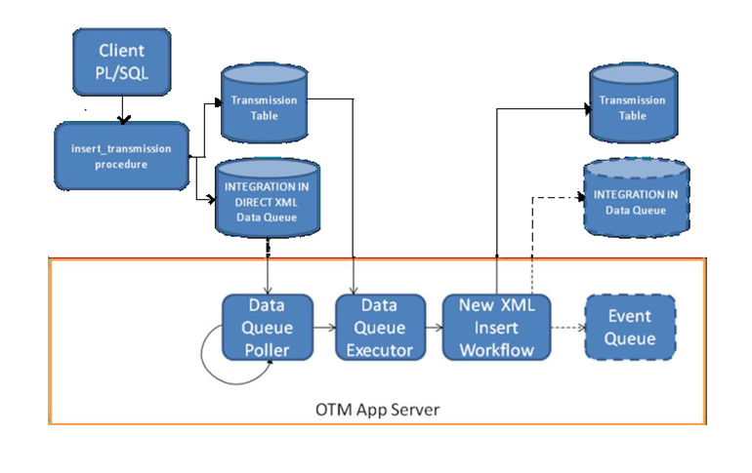

1. XML message passed to insert_transmission or insert_message procedure.
2. OTM procedure stores XML in Transmission table, data queue event in Direct Insert Data Queue and returns Transmission number to caller.
3. The Poller retrieves a number of events and calls the Executor for each event.
4. The Executor retrieves the message XML and calls the New XML Insert Workflow to perform the following Transmission pre-processing:

o Populate Transaction table data

o Populate Process Group data if present.

o Populate Transmission reference numbers if present.

o Publish New XML topic or queue event to INTEGRATION IN data queue if configured.

### Proof of Concept for the Direct XML Insert approach

#### Send / simulate a heavy load of Inbound transmissions by HttpPost integration to OTM (For e.g. NAP PROCON or CBU Procon)

#### Ensure that there this a backlog in the Transmission and there are transmissions in the FRESH status

#### Login to DRS and send a DRS request to OTM

#### If the configuration for the Direct XML insert is done right then

#### The DRS request (SAW Insert) transmission will be saved to the Data Queue

#### Data Poller will pick it up and insert into the transmission and transaction tables

#### The Transmission from the Deviation SAW is processed sooner than the FRESH transmissions pending to be processed in the I_TRANSMISSION table

#### Observe the timing of the Agent activity as a result of the SAW insert and the user interaction is handled in near real time